# Kafka

Kafka is a distributed publish-subscribe messaging solution. It is fast, scalable, and durable as compared to traditional messaging systems. If you think about traditional publish-subscribe messaging system, producers produce/write messages to topic and on another side consumers consume/read messages from this topic. Kafka is designed in a manner where topics can be partitioned and replicated across multiple servers.

Let us begin the step by step guide to see the working of kafka on the localhost.

STEP-1

Download kafka form the apache site and unzip it into the desired folder.

STEP-2

1. Go to **<kafka_dir>\config\server.properties** file and change log file location property 'log.dirs' as per your environment.

**log.dirs=<kafka_dir>\kafka-logs**

**2.** Go to **<kafka_dir>\config\zookeeper.properties** file and change data directory location property 'dataDir' as per your environment

**dataDir=<kafka_dir>\zookeeper-data**

STEP-3

1.Start the Zookeeper server first using the command:-

**<kafka_dir>\bin\windows\zookeeper-server-start.bat ..\..\config\zookeeper.properties**

2.Open up a new command line and start the kafka server with command:-

**<kafka_dir>\bin\windows\kafka-server-start.bat ..\..\config\server.properties**

**STEP-4**

Now you need to create topic to publish and subscribe messages. To create topic you just need to execute below command. As per below command you will be creating topic 'mytopic' with single partition.

**<kafka_dir>\bin\windows\kafka-topics.bat --create --zookeeper localhost:2181 --replication-factor 1 --partitions 1 --topic my_demo_topic**

After executing above command you must see below message on command prompt:

**Created topic "my_demo_topic"**.

STEP_5

Open a command prompt and execute below command. This command prompt will be treated as producer.

**<kafka_dir>\bin\windows\kafka-console-producer.bat --broker-list localhost:9092 --topic my_demo_topic**

STEP-6

Now open another command prompt and execute below command. This command prompt will be treated as consumer.

**<kafka_dir>\bin\windows\kafka-console-consumer.bat --zookeeper localhost:2181 --topic my_demo_topic**

If you will type any message in the producer command prompt and press enter, it will be consumed by consumer and you must be able to see the same message in consumer command prompt.

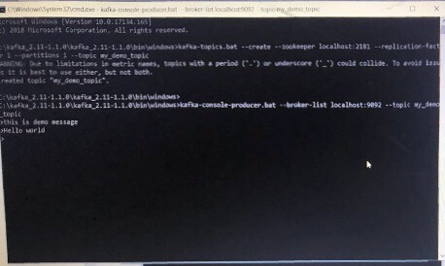

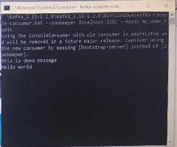

The upper image shows the producer command line and the lower one shows the consumer command line.

 If you reached at this stage, that means you are able to setup Kafka successfully in your windows environment.